Clean Water

Challenge

Where

The location is in a wooded area and the water is undrinkable. There is a river running next to the village and this is the water that needs filtering.

Brief

You must travel to a village where the water is undrinkable and create a water filter.

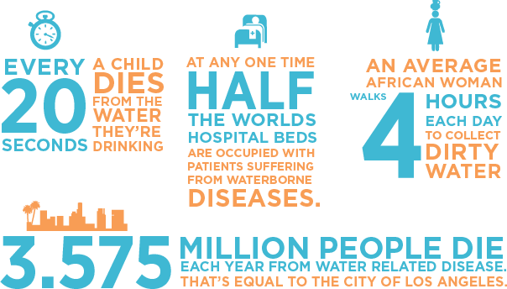

Things to bear in mind

* You must research your filter! And use materials readily available, speak to Kingsway staff about equipment available.
* The filter will need to provide enough water for a village so must produce clean water quickly