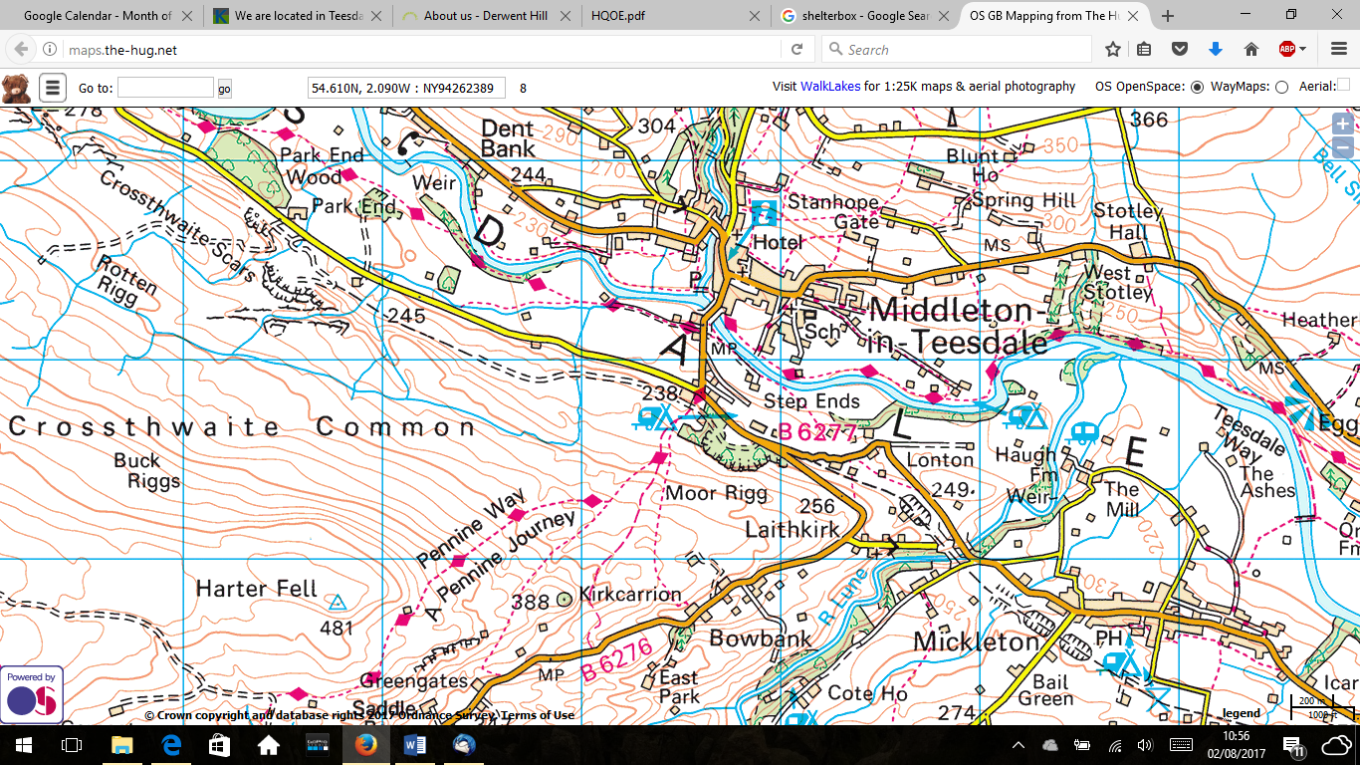Challenge

What to do

Once you’ve reached the stricken village you must select a suitable site to construct shelter for the family.

Where

You will receive the shelterbox and will need to deliver the aid to the village indicated on the map. By using footpaths and roads you must deliver the shelterbox to Kirkcarrion, the site of a village ruined in hurricane winds. You can use <http://maps.the-hug.net/> to find detailed maps to plan your route.

Brief

Deliver a shelter box to a family in a disaster zone. Once there help to provide the shelter.



Things to bear in mind

* The shelter box is heavy, you will need to come up with a solution to transport it in your group.
* You must stick to ‘rights of way’ and so make sure you’ve planned the route.
* It’s important to remember that travelling into hostile weather environments you need to take equipment and provisions to keep yourselves safe.